
Autumn 2025
UK Registered Charity Number 1120680
www.lightforchildren.org.uk

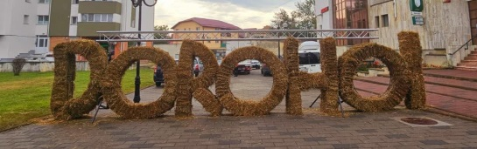
As we approach the end of 2025, we would like to thank you very much for your continued support throughout the year, which has enabled us to help many children and young people in Dorohoi and the surrounding area.
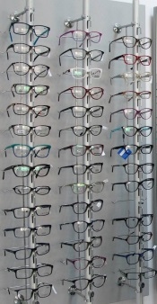
During the year, one of our priorities has been to support the children and young people living in state care when they have needed medication, dental work, ophthalmic care and new prescription glasses. As the young people have started to receive some financial help from the government and the prices of optician appointments and glasses have increased considerably, we have encouraged them to contribute to these expenses themselves whenever possible, hopefully enabling them to appreciate that this is something that they will need to budget for in the future when they become independent adults.
We have continued to sponsor a number of university students and are pleased to report that they have all successfully completed a further year of their studies. They continue to impress us, not only with their academic results but with the variety of extra curriculum activities that they are involved with, which nearly always benefit other people. They are all keen to give back to their communities and share the gifts and blessings that they have received.
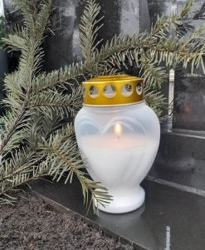
During 2025, we have continued to support several young adults who have lived with a chronic illness since they were very young children and still need regular hospital care. In April, we sadly lost another of our closest young friends, whose wife also sadly died in 2022. Their young teenage son is now being cared for by a very kind local family. He has been able to stay at his own school and church and is adjusting well to this new chapter of his life. We are very thankful to see him being so well provided for and to have the opportunity to remain in close contact with him.
At the beginning of the year, we were asked to help a young man who grew up in the care system in Dorohoi but had moved to work in a local town after leaving school. We have known him since he was very young and have always helped him with his glasses but in December/January he developed both a skin condition and painful joints, which meant that he could no longer work. Without health insurance or an income, he was unable to seek medical attention. As soon as we were made aware of his situation, we paid for him to attend a consultation with a dermatologist, at which point it became clear that he would need further, long-term medical care. We were able to pay for him to have health insurance and to move him back to Dorohoi, into a house owned by a local charity. There he was able to rest properly, receive three meals a day and be close enough to the hospital to attend regular appointments.
Following several months of investigations, he was diagnosed with a chronic autoimmune disease and prescribed an immunosuppressant drug which he has received weekly since the spring. Having spent the first few months of the year almost completely immobilised, he made steady progress over the summer months. We are delighted to say that he has gradually regained his strength and having felt so low, is now determined to make a brighter future for himself. In July, he applied to go to university and at the end of September, he moved to Cluj to study Finance and Banking. The doctors in Dorohoi, who have been particularly helpful and kind to him, are allowing us to liaise with them in his absence to ensure that he still has the medication and medical advice that he needs.
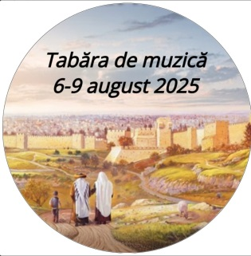
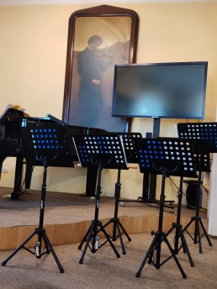
The highlight of the year was our first music camp, which ran for 4 days at the beginning of August, in Dorohoi. Each day, a group of children from the church orchestra enjoyed games, refreshments and rehearsals with recorders and hand bells. On the first day, they learned about Jesus’ pilgrimage to Jerusalem as a 12 year old boy and enjoyed a long walk to the outskirts of Dorohoi, stopping regularly to pray for people in the town. On the second day, they learned about George Enescu (1881 – 1955), a famous local musician and visited the George Enescu Museum. On the third day, the children dressed smartly and after further rehearsals, performed in a concert at the George Enescu Museum for their parents and grandparents.
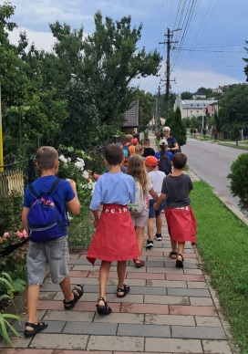
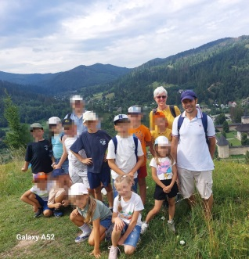
I had promised the children earlier in the year that we would go on a mission trip together during the summer; so on the fourth and final day of the camp, we hired a minibus and set off to visit elderly friends and relatives in two local villages. The children were received with great warmth as they played songs and prayed for each elderly person. From the villages we travelled to Siret to share a picnic in the park and then on to Sucevita to walk in the mountains and sing our favourite camp song, “I lift my eyes to the hills, where does my help come from?” It was a very special week in so many ways!

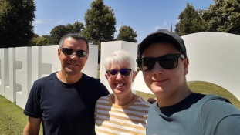
As a family, we were very pleased to be able to travel home together in July. During our visit to the UK, we spent time with friends and family in Burntwood and also enjoyed a weekend away in Liverpool and Southport. We very much appreciate your kind generosity towards us and the work of Light for Children. Thank you for making all these things possible during 2025!
With our love and thanks,
Helen, Costel and Costelus Cosman

