
August 2026
UK Registered Charity Number 1120680
www.lightforchildren.org.uk

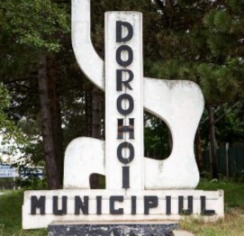
We wish to express our thanks for your ongoing support, which has enabled us to continue to help children and young people in Dorohoi and the surrounding area throughout the first half of 2026. As always, our priority has been to provide the children and young people living in state care with access to essential items such as medication, dental work, optician appointments and prescription glasses.
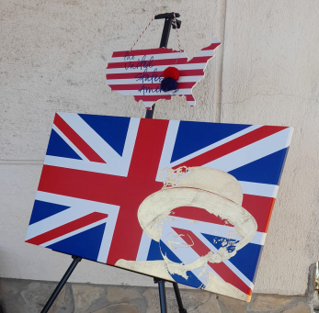
Once a month we have also joined with a family of American friends to host an English Club for the children and teenagers living in the apartments. Rather than formal lessons, we have organised games and fun activities, focusing on learning new vocabulary and having the confidence to use it. Above all, it has given us the opportunity to spend quality time with the children and to give them individual attention. At our last meeting before the school summer holiday, we asked everyone to wear red, white and blue and shared some of the differences between American English and British English. Both of our national anthems were played, our flags were flown high and the children enjoyed a barbecue!
Between January and June, we continued to sponsor a number of university students, several of whom were originally from the state care system. As always, we are proud to see how they have matured and developed into strong adults who are determined to succeed in their chosen professions. In our last newsletter we mentioned a young man who had been diagnosed with a chronic autoimmune disease and had enrolled at university in Cluj. He has now completed his first year, during which time he has also registered with specialists in Cluj, gradually taking over the responsibility of making his own appointments and obtaining his own prescriptions and medication. During the summer holiday he is staying on in his university accommodation and working part time at a shopping mall. We remain in regular contact with him but we are pleased to see how he is growing in confidence and taking responsibility for himself after a very difficult time prior to receiving his diagnosis.
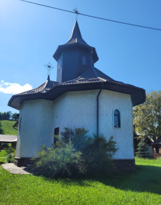
In May we had the pleasure of attending a wedding at a beautiful little church in the Romanian mountains. The groom was one of the original children from Dersca, who has amazed us with his resilience and sheer determination to overcome the many challenges he has faced. To see him looking so happy with his own family brought joy to our hearts. We were especially pleased to see several other young people at the wedding who had each been supported and encouraged by the groom during difficult times in their own lives, as well as other friends of his, who all spoke highly of his kindness and generosity.
During 2026, we have continued to support one young lady in particular who has been living with a chronic illness since she was a baby. She now spends more time in hospital than at home, so we keep in regular contact with her doctor and visit her as often as we can. We are very encouraged and grateful to see that in this particular hospital in Botosani, the doctor and nurses go above and beyond their professional duties to help and support their patients, taking a genuine interest in every aspect of their wellbeing and understanding the importance of offering unconditional love and care alongside medical treatment.
Throughout the academic year, I continued to teach the recorder in an after-school programme at a Christian school in Dealu Mare, on the outskirts of Dorohoi. At the beginning of July, I was asked to help with their English camp, during which a group of Year 2 children (aged 8/9) learned to perform a short musical version of the story of Zacchaeus, all in English! The children had a great time and were also touched by the message of the story that God’s love is bigger than our biggest mistakes.
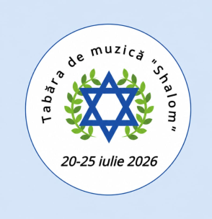
Later in July, we organised a music camp for the children from the church orchestra. The camp ran from Monday to Saturday at the GLIA Centre in Dorohoi. The theme this year was “Shalom”, a Hebrew word meaning peace, completeness and wholeness. We spent the week learning about the history of the Jews in Dorohoi, rehearsing Jewish music and other songs which speak of God’s love and peace, playing games and enjoying simple crafts. Although playing football had not featured at all in my original plan for the week, it became very clear on the first day that it had very much featured in the campers’ expectations, to the point where several of the boys actually came wearing their football boots! We quickly came to an agreement that worked well for the rest of the week!
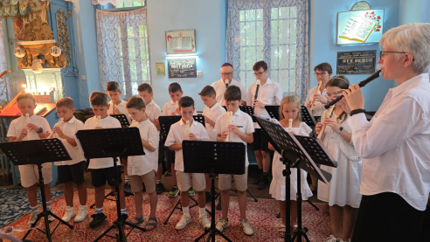
On the Wednesday, we visited Dorohoi train station, from where over 9000 Jews were deported to Transnistria in November 1941, singing two songs on the platform. On the Friday, we invited the children’s parents and grandparents to listen to them singing and playing a special programme of songs inside the Dorohoi Synagogue. As well as playing recorders and handbells, the children also sang in Romanian, English and Hebrew. It was very moving and something that we will always remember. On the Saturday morning, we hired a minibus and took the children to visit the Siret History Museum – Bucovina Jewish Holocaust Memorial, where they also played and sang several songs. We spent the afternoon in Gorovei, near to Dorohoi, enjoying a picnic and a walk in the forest.
As a family, we were very pleased to travel home for two weeks in June, spending most of our time in Burntwood with family and friends but also enjoying a lovely few days in north Wales with Lynn. We were particularly pleased to be at home for Dad’s birthday.
We continue to appreciate your support for both the work of Light for Children and for our family.

With our love and thanks,
Helen, Costel and Costelus Cosman

