 **Autumn 2024**

**UK Registered Charity Number 1120680**

www.lightforchildren.org.uk

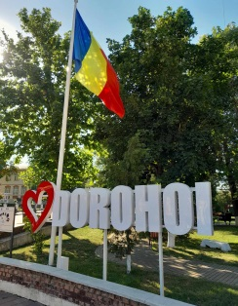 **Thank you** for your ongoing support throughout **2024**, which has enabled us to continue to help children and young people in Dorohoi and the surrounding area. As you are familiar with the work of **Light for Children**, in this newsletter I will attempt to share with you a number of ways in which lives have been touched as a result of your generosity. I have a responsibility to protect the identity of each child and young person here, so I am limited in terms of the amount of personal information that I can give but I hope that this letter will enable you to understand just how important and beneficial your contributions are.

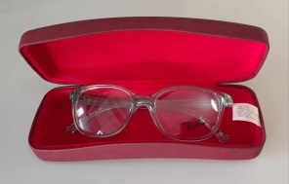 Children continue to enter the **care system** in Dorohoi for various reasons. They can arrive with very few items of clothing and footwear, so we are often asked to provide essential things for them. They sometimes have medical needs which have not been met due to difficulties in their previous homes. Accompanying new children to dental or optician appointments not only enables them to access the medical care that they need but also helps them to feel heard and valued. Such appointments provide an opportunity to talk to each child and to reassure them that in Dorohoi, they will be supported. Recently, I accompanied an eleven year old girl to have her eyes tested. The doctor established that without glasses, she had just 15% vision in one eye and 40% in the other eye. Thanks to your generous support and the care and empathy shown by the doctor and her team, the girl was able to choose a frame that fitted her well and we placed an order for her lenses. The girl’s glasses were ready today. She couldn’t have been happier when she received them and immediately realised what an incredible difference they make to her vision. As we stepped outside and she saw the outdoors for the first time through her new glasses, she beamed in awe of what she could see!

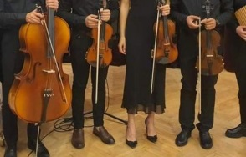 We continue to sponsor six **university students** who either have a connection with the care system or exceptional family circumstances which have determined our decision to support them. Amongst other subjects, these students have studied or continue to study medicine, nursing, psychology, teaching and law. They all have remarkable stories which demonstrate their courage and determination. One of the young men, who used to play the violin in our church orchestra, completed his first degree in the summer and has chosen to continue with his studies. As well as achieving academic success, he is a passionate leader and the dedicated president and concert master of the university orchestra. Earlier this month, we were delighted to receive photographs of him proudly leading his orchestra in concert at the Musikverein, Vienna, which we understand is considered to be one of the three finest concert halls in the world! We are incredibly proud of him and delighted to see him living his dream.

We have continued to support **young adults with special needs** who are trying to live independently within the community. It is often necessary to accompany them to medical appointments, help them to obtain monthly prescriptions and assist them with their applications for government benefits. Several of these young adults have chronic, life-threatening illnesses, so visiting them in hospital and encouraging them on their challenging journeys is very important. Sometimes it is the simple things that mean the most to them. One young lady asked me to keep a spare key to her apartment and to turn her heating on the day before she was discharged from a lengthy stay in hospital.

The hospital administration systems are all computerised now and each patient is required to provide a phone number for their **next of kin** as they enter the hospital. I regularly receive text messages which inform me that certain young people have either been admitted to or discharged from hospital. At such times, I am reminded of how important it is for each of us to have somebody reliable in our lives, to walk with us through the most difficult of days.

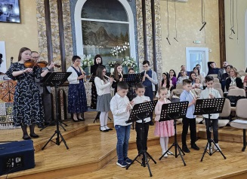 The **church orchestra** has continued to rehearse and perform in various local locations. As a number of our older members are now either university students or have married and are living in other towns, we are currently a much smaller group. However, we do have a number of younger children who are learning to play the recorder and we hope that they will gradually become much more involved. During the summer of 2024, we played in the courtyard of the original orphanage building in Dersca, which is now home to a group of young adults with special needs. We also visited a new history museum which has opened in Siret, where we played a selection of Jewish and Christian music.

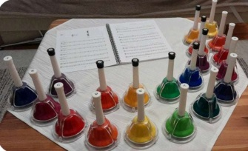 Over recent months, we have been fortunate enough to be able to buy new alto and tenor recorders which youngsters are now learning to play. In March, we were also delighted to introduce a set of tuned hand bells to the orchestra, which have already proved to be very popular. The orchestra has always been much more than a music group and I hope that the children and young people who are involved will be able to look back at these rehearsals and activities with great affection in the future. We have an “orchestra” group on Messenger, which I use to send reminders about rehearsals and generally communicate with everyone. One thing that I have noticed is that even when the young people grow up and are no longer able to attend, they all stay in the online group and continue to encourage the younger members of the orchestra. To me, this is a sign that their lives have been touched.

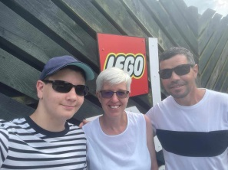 As a **family**, we were very pleased to be able to spend two weeks in the UK in July. As always, it was lovely to catch up with family and friends in Burntwood. Other highlights were a day at Legoland Windsor, to see the world’s first life-sized Lego Ferrari and a very enjoyable few days with friends at their caravan in north Wales. We continue to value and appreciate your generous support and loyal friendship, which together have enabled us to continue our work here over the last twelve months.

***With our love and thanks,***

***Helen, Costel and Costelus Cosman***