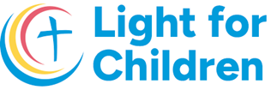**Summer 2024**

**UK Registered Charity Number 1120680**

**Thank you for your continued support during the first half of 2024.** We would like to let you know what has been happening in Dorohoi so far this year. As you are all aware, the war in Ukraine continues but the flow of refugees coming into north east Romania has completely slowed down. Several families of refugees have settled in Dorohoi and are extremely thankful for the peace and safety that they have found here. However, they remain painfully aware of the devastation and suffering that continues in their own country, just over the border.

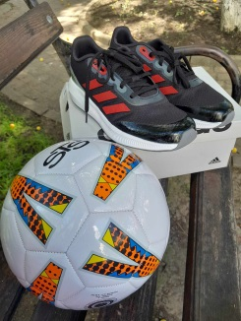 As always, we have continued to support the **children and young people living in the state run apartments in Dorohoi** with medication, medical tests, dental work, optician appointments and new glasses, as required. On 1st June, the children celebrated International Children’s Day with an afternoon of activities in the park. We were able to provide balls, skipping ropes, badminton rackets, hoops etc. to make this possible. The children have now finished school for the summer and have the opportunity to go on short holidays to either the seaside or the mountains, so we have been providing them with first aid kits and medication for their trips.

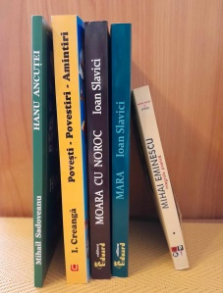

This academic year, we have supported **six students** who are studying in four different university cities in Romania. We are delighted to see that not only are they doing well academically but they are also very involved in their university communities. Alongside their studies, they are committed to things such as a university orchestra, an evangelical choir and the student advocacy board. They are clearly young people who are keen to give back to their communities and to use the skills and compassion that they have to encourage others.

***“Education is the most powerful weapon which you can use to change the world.” “Everyone can rise above their circumstances and achieve success if they are dedicated to and passionate about what they do.”* Nelson Mandela**

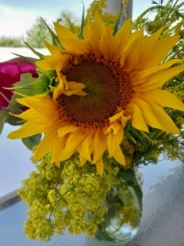 We are still in touch with many of the original group of children from **Dersca**, now in their early thirties. A number of them are married and have their own young families. We are privileged to still be part of their lives and to be included in both their family celebrations and trials. Several of these young adults are currently facing unimaginable health challenges but are doing so with remarkable courage and dignity, often with the loyal support of each other.

Most of these young adults belong to the Orthodox Church and have asked each other to be the godparents of their children. This lifelong commitment has formed a special bond between the families, which has been described as **“a bond that doesn’t depend on biology”**. This is particularly meaningful amongst adults who were separated from their birth families as children but who recognise and value the importance of family and connection in their adult lives.

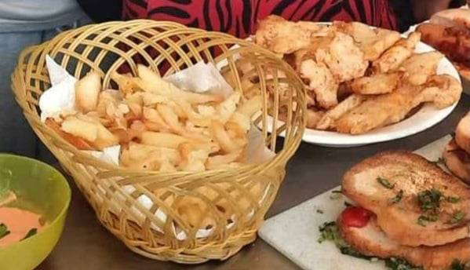 Throughout the last six months, I have continued to go into a local sixth form school each week to support the English teacher with a module of work about **British geography and culture**. In May, we were very pleased that Wendy and Dave Barnsley could join us for a few days in Dorohoi. Together we were able to support the class as they planned to cook a variety of British dishes in the school canteen, including fish and chips, bacon sandwiches and cottage pie! On the day itself, we were amazed by the way in which the young teenagers worked together in teams to efficiently produce some delicious food!

At the same school, we have also been able to support a number of pupils who would otherwise not have been in a position to take part in **extra curriculum activities**, including a trip to visit Peleș Castle in Sinaia and the Iași Botanical Garden.

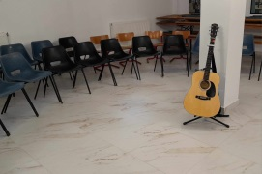 Recognising the need for more **youth work** to encourage **local teenagers**, we have worked closely with the leaders of several local churches to help organise meetings and activities specifically aimed at appealing to young people. Our role has often been in preparing the rooms and providing refreshments, as well as ideas for games and activities. Each time the meetings have been well attended and appear to be very much appreciated.

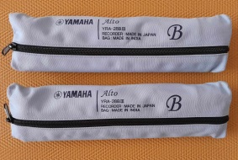

The **church orchestra** continues to meet each week to rehearse and two of the older girls have started to learn to play the alto recorder as well as the descant. We also have eight young children aged 6-8 years who are having individual lessons each weekend with a view to joining the orchestra in the near future.

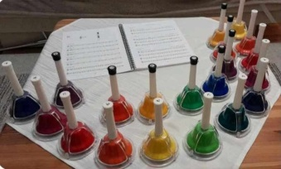 In March, we introduced the children from the orchestra to a set of **20 tuned hand bells**, which they absolutely love. For the younger children, I prepare sheet music using coloured notes, to help them. The older children are already able to read music in two voices, producing a lovely sound. At Easter they were able to play ***“Holy, Holy, Holy”*** written by ***Heber*** and they are currently rehearsing ***Brahms’ Lullaby*** for a baby’s blessing service later in July.

This is just a taste of the sort of things we have been doing so far this year. It goes without saying that all of this is only possible because of your faithful support. We can’t thank you enough for your kind generosity towards both our family and the children and young people of Dorohoi.

**With love and thanks,**

**Helen & Costel Coșman**