Autumn 2023
UK Registered Charity Number 1120680

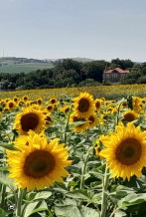
Thank you very much for your continued support during 2023. We wish to take this opportunity to share with you a brief overview of the work that has been done in Dorohoi, northeast Romania, over the last twelve months. We are very aware that none of this would have been possible without your support and so we are sincerely thankful for your generous provision. During the summer months we worked closely with Steve Powell, the Rugeley-based website developer behind Fellowship Studios, who has updated and transformed the Light for Children website. We are very grateful to Steve and kindly invite you to view the new website at this address www.lightforchildren.org.uk

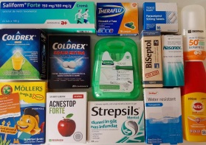
As in previous years, supporting the children and young people living in state care in Dorohoi has been our priority. We have continued to pay for their prescribed medication, medical tests, first aid and sunscreen products, optician appointments, glasses and dental care. As well as basic dental work, we have funded specialist treatment, oral surgery and the monthly tightening of dental braces, as required by a number of teenagers. We are very fortunate to have good working relationships with local doctors and dentists within the town and beyond.

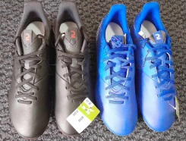
Throughout the year, we have encouraged children to take part in sport, providing suitable clothing, footwear and equipment for football, swimming and karate, as well as paying monthly subscriptions to a local sports club for those who are committed to attending weekly training sessions. We have also proudly supported a traditional folk dance and performing arts group for children from the apartments, who have successfully competed in competitions across the country.

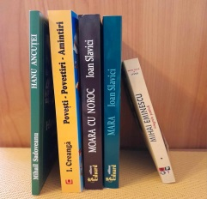
We have continued to fund schoolbooks and extra tuition as needed and have provided ongoing monthly sponsorship to several young adults to help cover their university expenses. These young people, both from the care system and local families, are studying medicine, nursing, teaching and psychology. We are very proud of them and their commitment to university life. We enjoy hearing about their progress and the ways in which they have taken on responsibilities both within their universities and their churches. They are always welcome to take part in any LFC activities during their holidays.
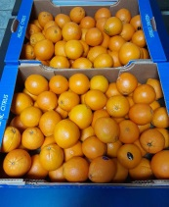
For Christmas 2022, we prepared small gifts of fruit, juice and chocolate for all the children and young people living in the state-run apartments. We also supported specific events being organised by other local charities to educate and encourage the young people, often providing refreshments and/or arranging for a suitable location to be used.

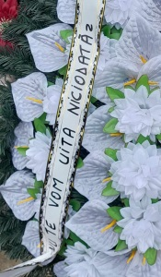
Several weeks ago we were very sad to say goodbye to one of our special young men, who sadly died, having lived with a chronic illness since he was a baby. His brother, who was one of the first children whom I met here in 1997, flew home from Germany to take care of the funeral arrangements, demonstrating love, compassion and an amazing sense of responsibility. Once again, I was touched by the way in which the other young adults came together to encourage each other at such a difficult time, in spite of their own health issues and challenging circumstances.
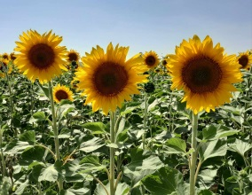
We are in regular contact with a number of young adults who grew up in the care system and who still require some support from time to time, particularly regarding medical paperwork and/or housekeeping. Whether they need assistance to apply for benefits, make home improvements, pay utility bills or support and encouragement whilst in hospital, it is a privilege to have their trust and we admire them for the many hurdles that they have been able to overcome.
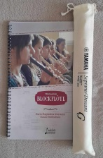
The church orchestra has continued to rehearse and play regularly and we have started to meet with younger children aged 6 and 7, who are keen to learn to play the recorder with a view to joining the orchestra in the near future. During the year, we have added a number of songs to our repertoire, notably God Save the King (in May 2023) and Behold our God, a powerful worship song inspired by Isaiah 40 v 12-14.
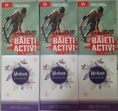
We have continued to encourage the children to read inspirational books, this year offering them daily devotionals written specifically for teenagers. We were also able to encourage their parents by gifting them books entitled “The Five Love Languages of Teenagers – The Secret to Loving Teens Effectively”, by Gary Chapman.

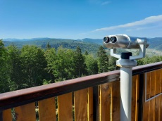
At the beginning of September we hired a minibus and took the orchestra on a day trip to the mountains, where they had a fantastic time taking a chairlift to enjoy magnificent views, hiring quadracycles to race through a park and learning how to scale a climbing wall for the first time! We are particularly thankful to be able to offer the children and teenagers such opportunities to peacefully enjoy the outdoors together at a time when so many of their contemporaries in nearby conflict zones are facing such unimaginable suffering.

As a family we enjoyed spending two weeks in England at the beginning of August. We are blessed to have so many people in our lives who have offered us faithful support and friendship over the years. We can only thank you and pray that God will bless you for your selfless commitment and endless generosity.
With love,
Helen, Costel and Costelus Cosman

