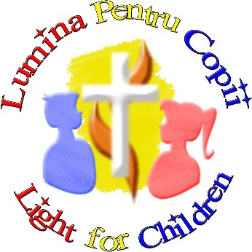

L i g h t f o r C h i l d r e n

Summer 2021

UK Registered Charity Number 1120680
_____________________________________________________________________

In an effort to bring you up to date with our news, I would like to tell you about some of the projects that we have been involved with over the summer months. I would also like to thank you for your continued support which has enabled us to work throughout the Covid-19 pandemic. Without your support and encouragement, none of this would have been possible.

In Romania, over one million people have been infected with Covid-19, resulting in approximately 35,000 deaths since the start of the pandemic. Approximately 700 - 1000 new cases are still being identified each day. Vaccinations are widely available to everyone from the age of 12 upwards but it is thought that only 25% of the population have been fully vaccinated so far.

Practically speaking, restrictions have been lifted in many ways. Whilst masks are still required inside public places and social distancing is encouraged, almost everywhere is now open. The schools were physically closed for much of the academic year 2020/2021, but we are hopeful that they will open again for all children on 13th September 2021.
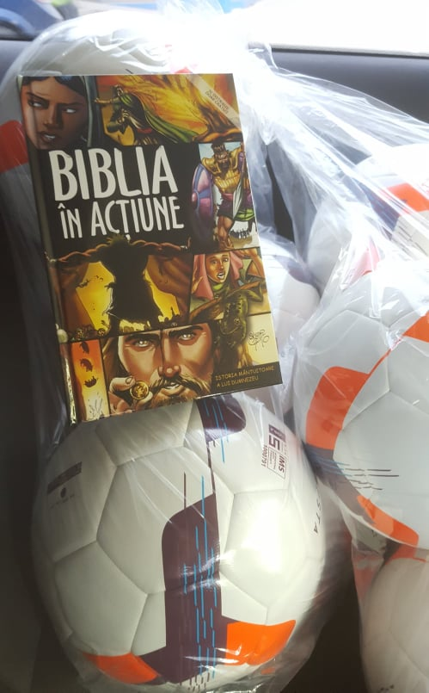

The children living in the state-run apartments have had a great summer. Although they are still tested regularly, very few have tested positive in recent months. At Easter (which was the first weekend in May) we gave each apartment either a football or a set of badminton rackets. We also received a donation of Bibles from a Romanian organisation, which we were able to give to each apartment. The Bibles are very popular as the stories are all presented in cartoon strips.

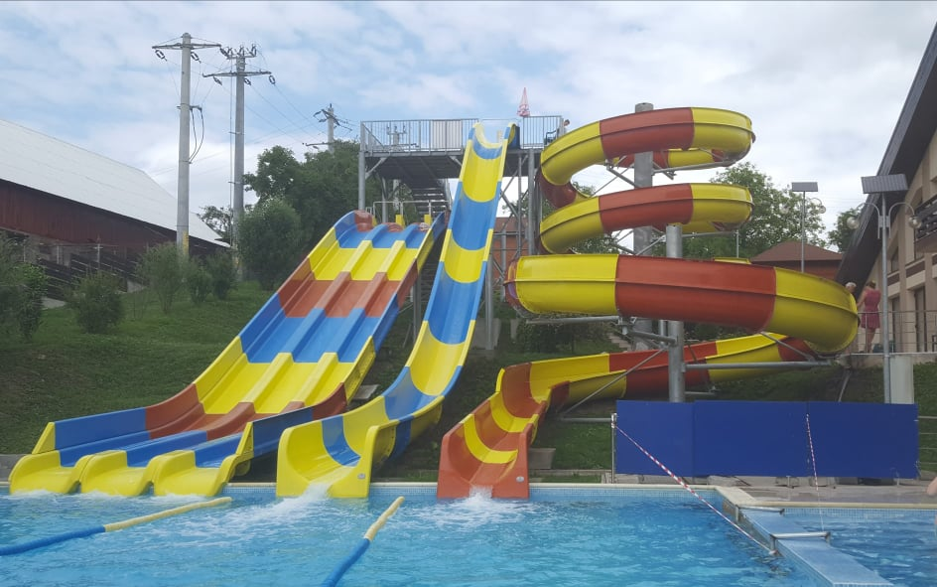
In July and August, the children attended various camps in the mountains as well as trips to the seaside. In Dorohoi, the children have had access to an outdoor swimming pool and various activities have been organised to give them the best possible break after such a difficult time.

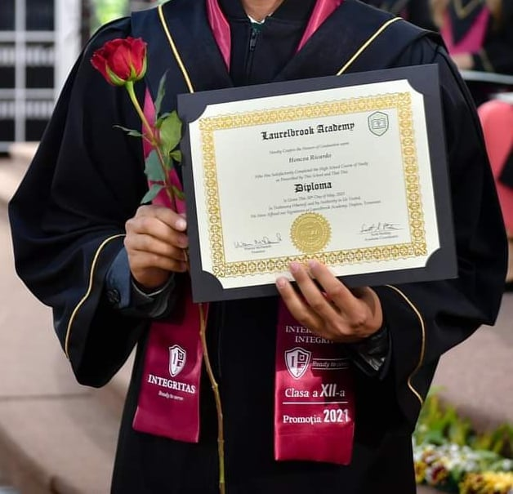
We are delighted to report that the students whom we have supported throughout the year have done very well. The young man whom we supported through the Christian sixth form in Targu Mures, completed his studies in June and now has a place to go to university, where he will study Pedagogy, with a view to becoming a teacher. In his final school year, as well as overseeing his small ironing business, he also invested in a good quality printer, which he used to help his colleagues print their essays and projects, all for a small charge!


We have continued to support children needing medication, dental care and glasses. Following extended periods of online schooling, we have seen a rise in the number of children needing glasses. Over recent months, we have also been approached to fund glasses for several adults with learning difficulties, who also live in the care of the state, just outside Dorohoi. These young adults have been extremely grateful for our help and very enthusiastic about receiving their glasses!

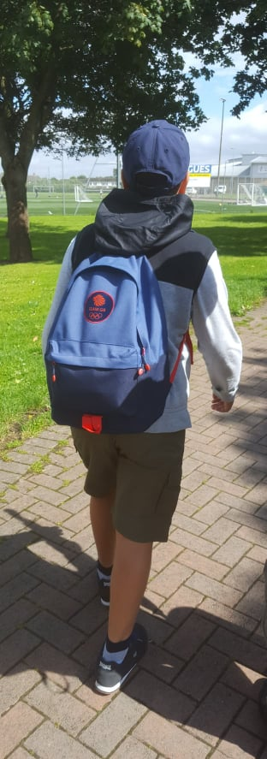
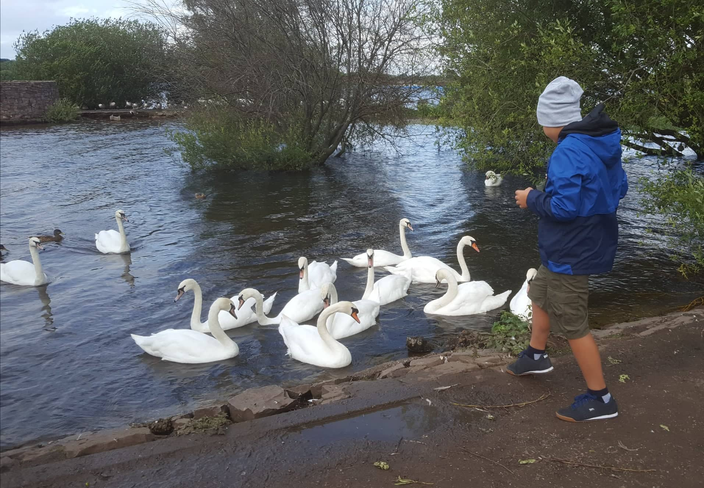
We were delighted to be able to go to England as a family for two weeks in August, having not been home since July 2019. All of the paperwork and tests required to be able to travel were something of a challenge but all worth it in the end! It was lovely to catch up with family and friends, visit Chasewater and local parks, not to mention our daily trip to Burntwood Leisure Centre for a swim!

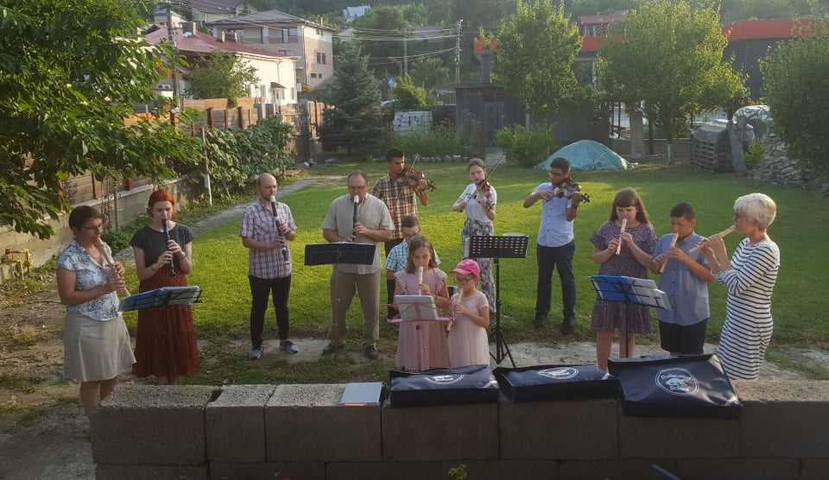
Having met again to rehearse with the church orchestra on a regular basis since Easter, we’ve been able to play on a number of occasions in our local church this summer. One evening in July, we prepared a special programme of songs and visited elderly members of the congregation, to play hymns in their gardens. As it is the last week of the school summer holidays, we’ve got a couple of special things planned for these children.

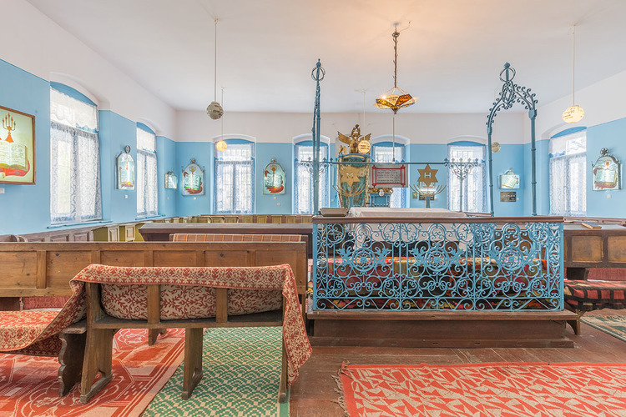
On 9th September, we will be visiting the Synagogue in Dorohoi, to learn about the history of the Jewish community in the town and to play several Jewish melodies. The children will receive copies of the book “Number the Stars” by Lois Lowry, an inspirational work of historical fiction about the escape of a Jewish family from Copenhagen, Denmark, during World War II.

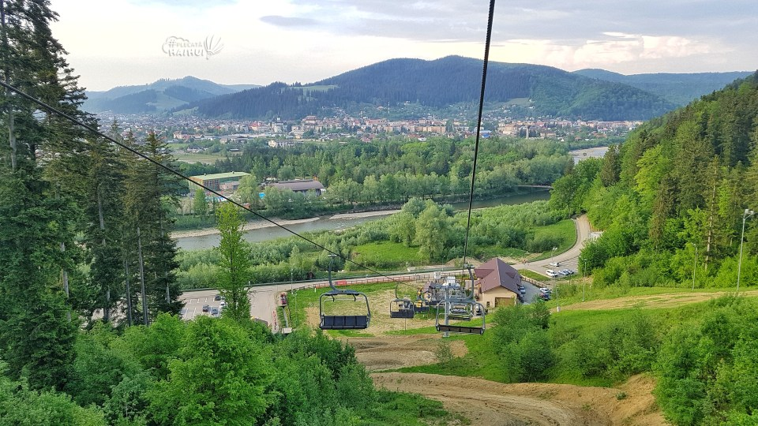

On 11th September, we will be travelling to the mountains by minibus, where we will spend a day exploring an adventure park in Gura Humorului.

Thank you for enabling us to offer support to so many children and young people here in Dorohoi. As well as trying to meet their basic medical and educational needs, with your support we really are able to offer them opportunities to thrive, which they otherwise may not have had.

Helen and Costel Cosman.

